Topic 5 / Chapter 7

Database Management & CIS 1246

|  |  |
| --- | --- |
| Author: | Christopher Sigouin |
| Date: | March 3 |
| Date Due: | March 3 |
| Assignment: | Topic 5 |
|  | Task: 1 |
|  |  |
|  |  |
| Mark: ____________ | |

**Create the ConstrucCo Database and table EMPLOYEE given the table structure and data shown on page 282 Fig. P7.1 of your text. No script file is provided for this one time creation. Now perform the following request:**

1. **Create the database.**

Create Database ConstrucCo;

Use ConstrucCo;

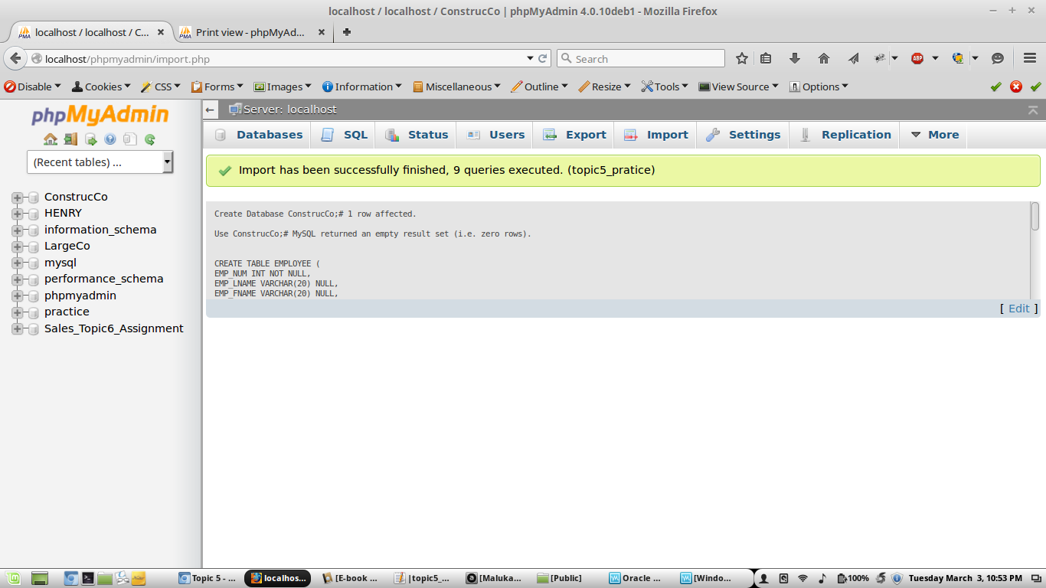

1. **Create Employee table.**

CREATE TABLE EMPLOYEE (

EMP_NUM INT NOT NULL,

EMP_LNAME VARCHAR(20) NULL,

EMP_FNAME VARCHAR(20) NULL,

EMP_INITIAL CHAR(1) NULL,

EMP_HIREDATE DATE NULL,

JOB_CODE CHAR(3) NULL,

EMP_YEARS INT NULL

);

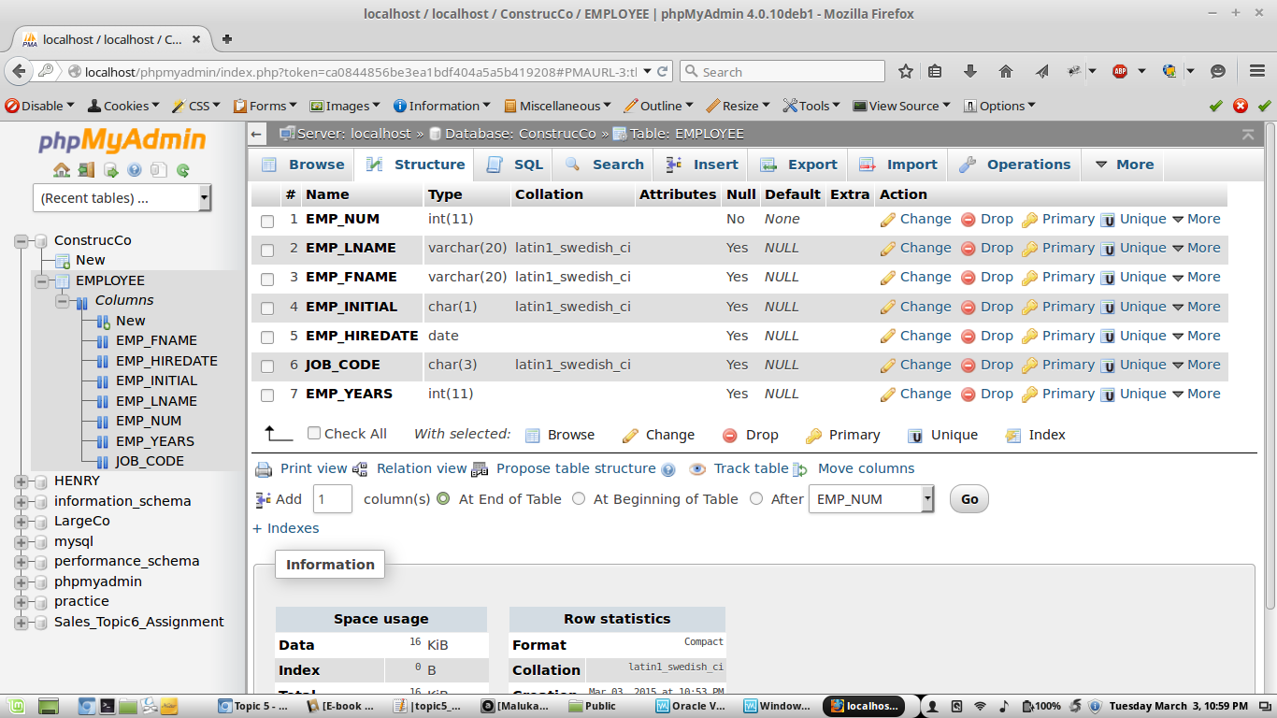

**Insert the first 6 rows of the table as shown on page 282 of your text.**

INSERT INTO EMPLOYEE VALUES('101','News','John','G','08-Nov-00','502','12');

INSERT INTO EMPLOYEE VALUES('102','Senior','Davis','H','12-Jul-89','501','23');

INSERT INTO EMPLOYEE VALUES('103','Arbough','June','E','01-Dec-86','503','16');

INSERT INTO EMPLOYEE VALUES('104','Ramores','Anne','K','15-Nov-97','502','25');

INSERT INTO EMPLOYEE VALUES('105','Johnson','Alice','K','01-Feb-93','502','19');

INSERT INTO EMPLOYEE VALUES('106','Smithfield','William','','22-Jun-04','500','8');

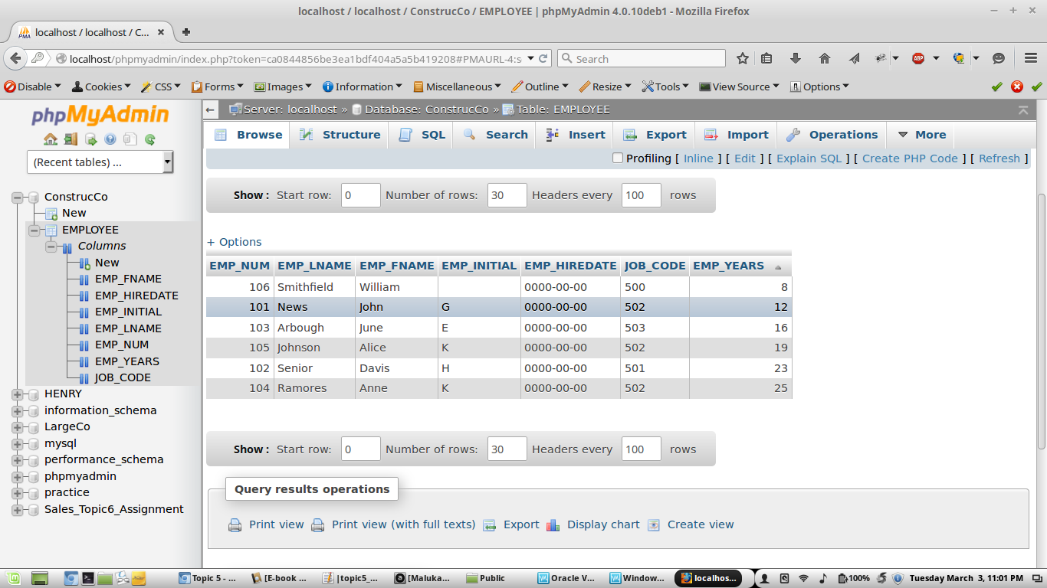

**Use the SQL command to list all the table data content.**

SELECT * FROM EMPLOYEE

